**INSTRUCTIONS MANUAL**

A. Introduction

1. What is the mobile application about?

Energy Consumption Monitoring is an auxiliary mobile application that allows you to calculate the rate of energy per kilowatt-hour (KWH) by entering total amount and the total kwh used by referring to the household/establishment’s electric bill. This app also enables you to view previous data consumption history. Your data will always be within easy reach. Uhmkay heh.

1. Instructions on how to install the application

* On your device, install the APK file of the application provided by the developers of the system.
* Install and follow the on-screen instructions to complete the process and get the accessibility of the app.

1. Ensuring security and control of ownership of the mobile application

After installing the app on your device, you are required to input a code to gain access to the app's features.

B. Managing User Contacts

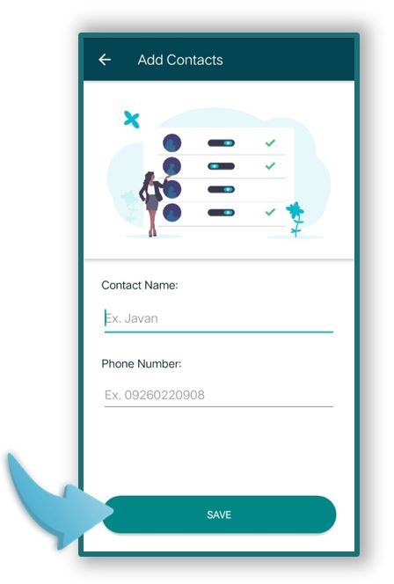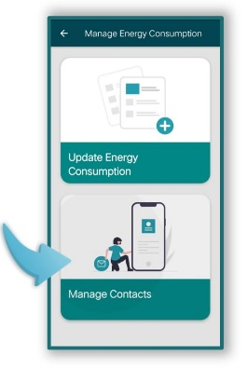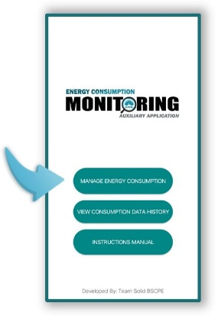Manage Contacts first by clicking the Manage Energy Consumption feature by entering the name and contact number of the individuals who consume electricity within the household/establishment.

C. Updating and Logging Energy Consumption of Users

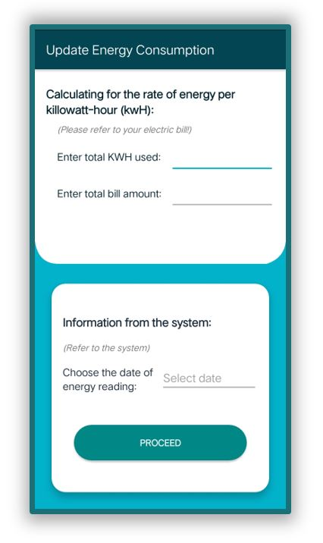 Update User’s Energy Consumption by entering the total KWH used and the total bill amount by referring to the household/establishment’s electric bill. The system will be calculating the rate of energy per kilowatt-hour.

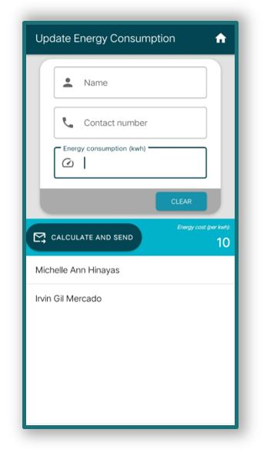Upon proceeding, you may choose among the recipients listed below and enter his/her total corresponding energy consumption by referring to the kadtung slave chuchuIRVIN GIL MERCADO. After inputting, click the Calculate and Send button, the system application will send a text message that notifies the recipient his/her energy consumption and amount to be paid.